**Daily Scrum or Standup Meeting**

Team name: Alpha Squad

Scrum Master: Isaak Johnson

Date: Nov 18

|  |  |  |  |
| --- | --- | --- | --- |
| **Team Member** | **What did you do since the last scrum?** | **What do you plan to do before the next scrum?** | **What obstacles do you have?** |
| Alex Beeston | Wrote unit tests for the live page | Determine is I have written sufficient unit testing | I’m not sure what the MVP is for unit testing. |
| Joey Carlisle | Added an admin dashboard  added styling  admins can grant adminship | finish testing | I’ve been dragging my feet writing the tests |
| Isaak Johnson | Nothing | Finish unit tests | Way too busy with other homework |
| Ben Taylor | Nothing | Finish the individual user’s bids on the different pages | Other classes and work. |

# Burndown

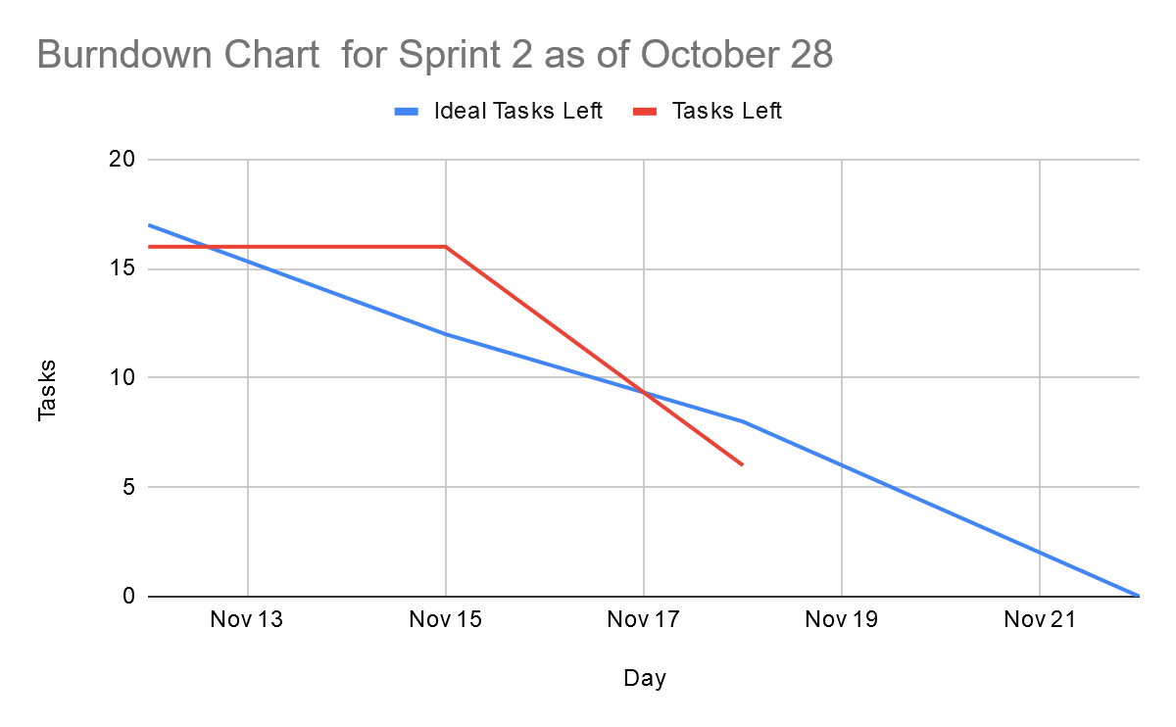

# Screenshot of you project board

